Jackie Folsom, Legislative Director: 802-426-3579, crkdbrks@aol.com Sergeant-at-Arms 802-828-2228

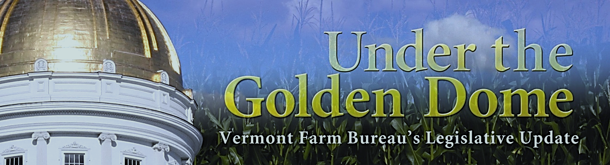

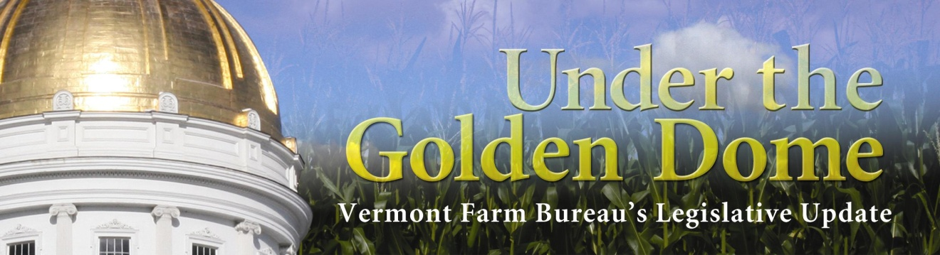

When you call the Sergeant-at-Arms: Please leave your name & phone number
Say, “I’d like to leave a message for ___,” Leave a clear message, such as:
“I do not support…” OR I am asking for your vote on ___”
Please refer to a bill number or name whenever possible.

THIS IS FOR THE USE OF FARM BUREAU MEMBERS ONLY!!
A WHITE PAPER ON ACT 145 (H.626)
Relating to control of pesticides, pollinator protection, neonicotinoid pesticides and treated article seed
The original purpose of this bill was to prohibit the use of neonicotinoid pesticides until rules for the sale, use or application of them were developed by VAAFM.
However, after many dairy farmers testified in both the House and Senate Ag Committees about the need for treated seeds (and beekeepers also testified about the challenges of treated seeds being used near their hives), a compromise bill was passed and signed into law by the governor.
The bill now has two sections:
Upon the recommendation of the Agricultural Innovation Board (AIV), the Agency of Agriculture MAY adopt by rule
- Best Management Practices, standards, procedures and requirements relating to the sale, use, storage, or disposal of treated articles which have been determined by AIV to have a hazardous or long-term deleterious effect on the environment, presents a likely risk to human health, or is dangerous;
- Requirements for the response to or corrective actions for exigent circumstances or contamination from a treated article that presents a threat to human health or the environment;
- Requirements for the examination or inspection of treated articles the AIV has determined will have hazardous or long-term deleterious effect on the environment, presents a likely risk to human health, or is dangerous
- Requirements for persons selling treated articles to keep or make available to the VAAFM records of sale of treated articles and what treatments were received;
- Requirements for reporting of incidents resulting from accidental contamination from or misuse of treated articles.
At least 30 days prior to filing the rule, VAAFM shall submit a draft rule to the Senate and House Agriculture Committees for review. These rules -after consultation with AIV – SHALL adopt BMPs for the use of neonicotinoid treated article seeds in Vermont. Rules shall include:
- Establishment of threshold levels of pest pressure required prior to use of treated article seeds;
- Availability of nontreated article seeds that are not neonicotinoid treated article seeds;
- Economic impact from crop loss as comparted to crop yield when these seeds are used;
- Relative toxicities of different treated seeds and the effects of neonicotinoid treated article seeds on human health and the environment;
- Surveillance and monitoring techniques for in-field pest pressure;
- Ways to reduce pest harborage from conservation tillage practices;
- Criteria for a system of approval of neonicotinoid treated article seeds.
To implement the rules required, VAAFM SHALL work with farmers, seed companies and other relevant parties to ensure that farmers have access to appropriate varieties and amounts of untreated seed or treated seed that are not neonicotinoid treated article seeds.
On or before February 15, 2023, the AIV SHALL submit a written report to the House and Senate Agriculture Committees regarding whether BMPs should be adopted for the use of treated article seeds that are not neonicotinoid treated article seeds. The report shall include:
- A summary of the AIV’s review of treated article seeds that are NOT neonicotinoid treated article seeds, including identification of treated article seeds that may have adverse effects on human health or the environment;
- A recommendation of whether BMPs for treated article seeds that are NOT neonicotinoid treated article seeds should be adopted and whether they should be adopted rule; and
- Proposed BMPs for treated article seeds that are NOT neonicotinoid treated article seeds.
Near the end of the session, that was the entirely of the new language. No ban or prohibition of selling neonicotinoid treated seeds was passed. However, Senator Pearson from Senate Ag was adamant that the concerns raised by the beekeepers were addressed. Subsequently, a section was added entitled Monitoring of Pollinator Health which SHALL require VAAFM to monitor managed pollinator health to establish pollinator health benchmarks for Vermont, including:
- Presence of pesticides in hives;
- Mite pressure;
- Disease pressure;
- Mite control methods;
- Genetic influence on survival;
- Winter survival rate; and
- Forage availability.
On or before March 1, 2024, VAAFM SHALL submit a copy of the proposed rules to the Senate and House Agriculture Committees for review. These rules SHALL NOT be filed as the final rules until at least 90 days after the rules go to the General Assembly or July 1, 2024, whichever shall occur first.
The final section set up two new permanent classified positions at VAAFM authorized for FY23 for the purpose of staffing the Residuals Management Program, supporting the AIV and enforcing and reviewing the use of treated article pesticides in the State. The positions shall be funded from the revenue raised from the registration of soil amendments and the registration of dosage from animal health products and feed supplements.
Vermont Farm Bureau was supportive of the removal of the ban and prohibition of neonicotinoid treated seeds in the original language, but also was cognizant of our many beekeeper members who had testified for the ban. Our policy on biotechnology is:
- We oppose any legislation restricting the uses of any product that has been approved by the USDA, FDA, EPA, etc.
- We support unbiased, scientifically based evaluations concerning human and animal safety as well as the environmental impacts of biotechnology and the right of farmers to use these products based on these evaluations.
Please note the highlighted words in this report. It’s important to recognize the difference between SHALL and MAY and how and when they are used. (Using the word SHALL means something has to happen; using the word MAY means it’s at the discretion of the rule-maker). Also, there are several places in this Act that require VAAFM to report back to the Senate and House Agriculture Committees; these were put in as “check-backs” to the General Assembly. There has been concern under the golden dome that sometimes rules are finalized which are not the intent of the Legislature and sometimes done without input of the effected businesses or individuals. The check-back will allow relevant committees the opportunity to review the proposed rules and make sure legislative intent was followed.
Sadly, we do NOT currently have any policy on beekeeping or pollinator issues. Throughout the conversation on H.626, we have encouraged our beekeeping members to develop policy and work through the county system this fall so that we have a robust and representative set of policies in support of their industry.
Also, we will keep track of endeavors on the part of both the Agency of Agriculture and the Agricultural Innovation Board as they work (as mandated by the General Assembly) to interact with farmers, seed dealers and others to develop the BMPs as required by Act 145.
Questions to ask candidates:
- What is your understanding of the use of treated seeds on farms? Do you know why farms growing corn require these seeds? Have you spoken with farmers about this issue?
- What is your understanding of treated seeds on bees? Have you spoken with beekeepers about this issue?
- Would you support a ban or prohibition on the sale of neonicotinoid seeds? Why or why not?
Policy development issues:
To all VTFB members: what other policy do we need regarding biotechnology? How can we balance the needs of both the farmers growing corn and the beekeepers? How can we support all types of agriculture to be successful? What is missing from our policy that would help explain our position on these issues?
Thanks – Jackie Folsom, Legislative Director, and the team!!

